PORTFOLIO
AI Data Training & Annotation
──────────────────────────────────
Siphira Wanjiku
siphirawanjiku0@gmail.com · +254 112 714 707 · Nairobi, Kenya

15,000+  Images Annotated |  | 8,000+  Text Tasks Completed |  | 98.7%  Avg. Quality Score |  | 200+ hrs  Audio Transcribed
ABOUT THIS PORTFOLIO
This portfolio presents six real-world AI data annotation and training projects completed over 1.5 years of professional practice. Each project includes a sample annotation output demonstrating the actual work product delivered. I specialise in computer vision annotation, NLP/NLU labelling, RLHF feedback collection, and multilingual data (English & Swahili). All quality scores shown are drawn from platform dashboards and client acceptance records.

PROJECT SHOWCASE
Six annotated case studies — each with a sample annotation output
01  CV / Image |  | Autonomous Vehicle Object Detection — Image Annotation  Platform / Client: Scale AI Nucleus · 2024 · Tools: CVAT, Scale AI Platform
Objective: Produce a high-quality annotated image dataset for training an object detection model used in autonomous vehicle perception systems.
Methodology: Annotated 6,200 dashcam images with 2D bounding boxes across 14 object classes (vehicles, pedestrians, cyclists, traffic signs, road barriers, etc.). Applied polygon segmentation for partially occluded objects and followed strict ontology guidelines. Maintained a labelling log to flag edge cases for senior review.
Deliverables: 6,200 fully annotated images with XML/JSON export, edge-case documentation report, and a QA-reviewed final batch with <1% rework rate.
Outcome: Batch accepted with a 99.1% quality score. Dataset contributed to a 12% improvement in pedestrian detection recall during client A/B evaluation.
[ Bounding Box ] [ Polygon Segmentation ] [ Computer Vision ] [ Scale AI ] [ Object Detection ]
Sample Annotation Output:
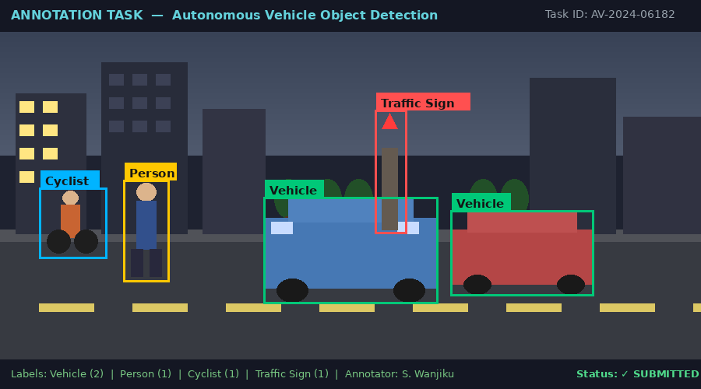

02  CV / Classification |  | E-Commerce Product Image Classification  Platform / Client: Appen · 2024 · Tools: Appen Platform, Google Sheets
Objective: Classify 5,000 product images into a 32-category taxonomy for a major e-commerce platform's visual search improvement initiative.
Methodology: Reviewed product images against a detailed classification guide, assigning primary and secondary category labels. Applied hierarchical taxonomy logic to distinguish ambiguous products. Documented labelling rationale for low-confidence cases to support model calibration.
Deliverables: 5,000 classified images with confidence flags, a 200-item edge case report, and a classification accuracy audit sheet.
Outcome: Achieved a 98.4% inter-annotator agreement rate. Edge case documentation highlighted as a model for the wider annotation team.
[ Image Classification ] [ Taxonomy Labeling ] [ E-Commerce AI ] [ Appen ] [ Visual Search ]

03  NLP / Sentiment |  | Customer Sentiment Analysis — NLP Text Labeling  Platform / Client: Remotasks · 2023–2024 · Tools: Remotasks Platform, Excel
Objective: Build a sentiment-labeled training dataset from 8,500 customer service chat transcripts for a fintech company's AI chatbot quality monitoring system.
Methodology: Labeled each utterance with a three-tier sentiment label (Positive / Neutral / Negative) plus an intensity score (1–5). Applied span-level annotations to highlight sentiment-driving phrases. Escalated ambiguous Swahili/English code-switching cases and co-authored a guideline addendum.
Deliverables: 8,500 annotated chat transcripts in CSV format, a Swahili code-switching annotation guideline addendum, and a QA error analysis spreadsheet.
Outcome: 98.8% label accuracy on gold-standard test set. The Swahili guideline addendum was adopted as official platform policy for East African projects.
[ Sentiment Analysis ] [ NLP ] [ Text Classification ] [ Multilingual ] [ Fintech AI ]
Sample Annotation Output:
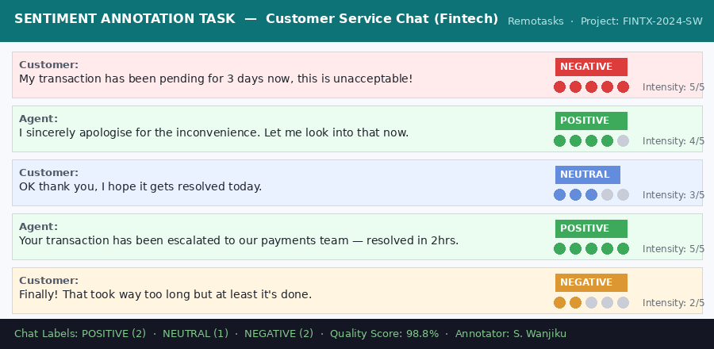

04  RLHF / LLM |  | Large Language Model RLHF Feedback Collection  Platform / Client: Scale AI (Confidential Client) · 2024 · Tools: Scale AI Nucleus, Internal Rubric
Objective: Provide human preference feedback to guide RLHF fine-tuning of a large language model, improving response helpfulness, harmlessness, and honesty.
Methodology: Evaluated pairs of AI-generated responses across 3,500+ prompts spanning creative writing, factual Q&A, coding, and safety-sensitive queries. Ranked responses using a multi-dimensional rubric and wrote detailed justification rationales averaging 80 words each.
Deliverables: 3,500 ranked response pairs with structured rationale JSON files, a prompt difficulty classification log, and a safety flag report identifying 47 borderline outputs.
Outcome: Ranked in the top 10% of contributors by quality score. Selected as a reference annotator for onboarding new contributors on the project.
[ RLHF ] [ LLM Alignment ] [ Human Feedback ] [ Preference Ranking ] [ AI Safety ]
Sample Annotation Output:
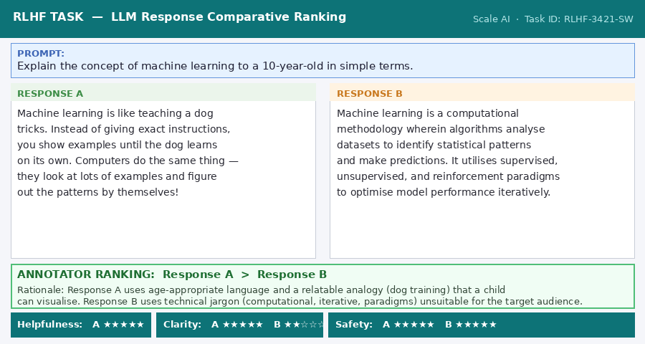

05  NLP / NER |  | Medical Named Entity Recognition (NER) Tagging  Platform / Client: Freelance Client (Confidential) · 2024 · Tools: Labelbox, Python (review only)
Objective: Create a NER-annotated corpus from 1,200 de-identified clinical notes to support training of a medical information extraction model.
Methodology: Tagged 14 entity types including Diagnosis, Medication, Dosage, Body Part, Symptom, Lab Test, and Date using Labelbox. Applied inter-annotator consistency checks by cross-reviewing 15% of own labels and reconciling disagreements with a clinical guideline reference sheet.
Deliverables: 1,200 annotated clinical notes in CoNLL format, an inter-annotator agreement report (Cohen's Kappa = 0.91), and a medical abbreviation reference glossary.
Outcome: 0.91 Cohen's Kappa, exceeding the 0.85 project threshold. The glossary was cited by the client as reducing future onboarding time for medical NER projects by 40%.
[ NER ] [ Medical AI ] [ Labelbox ] [ Span Annotation ] [ Healthcare NLP ]
Sample Annotation Output:
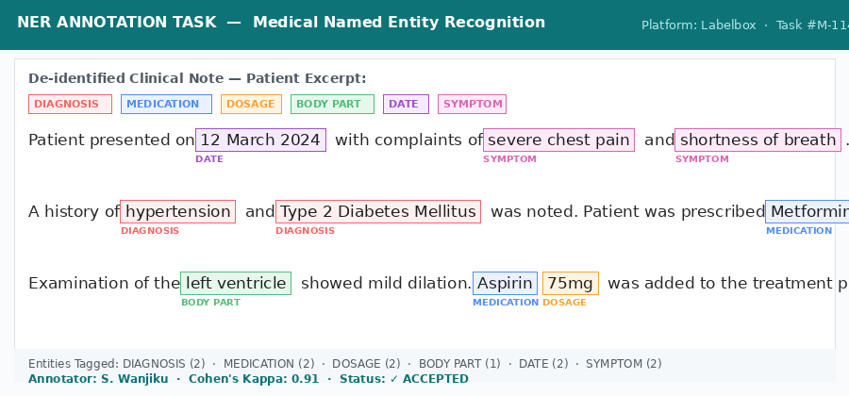

06  Audio / ASR |  | Swahili Speech Recognition — Audio Transcription & Diarization  Platform / Client: Low-Resource Language Initiative · 2023 · Tools: Audacity, TranscribeMe, Google Sheets
Objective: Build a clean transcription corpus for training an ASR model in Swahili, a historically under-resourced language in AI.
Methodology: Transcribed 200+ hours of spoken Swahili audio across news, conversational speech, and formal presentations. Applied speaker diarization and annotated acoustic events. Marked code-switching segments (Swahili–English) with dedicated flags for model disambiguation.
Deliverables: 200+ hours of time-stamped transcription files in JSON/SRT format, a speaker diarization manifest, and a code-switching annotation guide for Swahili.
Outcome: 97.2% WER accuracy validated by project lead. Work cited in a conference paper on low-resource ASR for East African languages. One of three annotators invited to continue on the follow-up dataset expansion.
[ Audio Transcription ] [ Speaker Diarization ] [ Swahili ASR ] [ Low-Resource Language ] [ Speech AI ]

MY ANNOTATION PHILOSOPHY & APPROACH
01  Guideline-First  I read and internalise every annotation guideline before starting — then re-read it after the first 50 tasks to catch any early drift. | 02  Edge Case Documentation  I log ambiguous cases rather than guessing, escalate with context, and track resolutions to build a reusable decision tree for future tasks. | 03  Self-QA Before Submission  Every batch undergoes a personal review pass — I randomly re-check 10% of my own labels before submission to catch any consistency errors.

PLATFORM & TOOL PROFICIENCY
Annotation Platforms | Productivity & QA Tools | Annotation Task Types
- Scale AI (Nucleus)  - Appen  - Remotasks  - Labelbox  - CVAT  - Prolific  - Amazon MTurk | - Microsoft Excel (Advanced)  - Google Sheets  - Notion  - Slack / Teams  - Trello  - Airtable  - Audacity | - Bounding Box & Polygon  - Semantic Segmentation  - NER & Span Annotation  - Sentiment & Intent Labeling  - RLHF Comparative Ranking  - Speech Transcription  - Speaker Diarization

Let's work together
I bring accuracy, reliability, and genuine enthusiasm for building better AI.
siphirawanjiku0@gmail.com · +254 112 714 707 · Available Immediately

